Weather Forecast

* Initially user has to login to use the application.
* On the landing page the user needs to login. Incase he does not have an account he needs to register.
* Registering a user takes from user username ,password ,location , and a security question and its answer.
* After registering, the user is redirected to welcome page.
* It by default displays forecast for the location specified by user during registration.
* The user will be able to check weather forecast for locations around the world.
* He needs to select if the temperature needs to be displayed in degree or Fahrenheit.
* Also, the forecast for coming # days needs to be specified by user.
* Weather forecast details include
  + max/min temp in Celsius by default(user can change it to Fahrenheit )
  + One word to describe weather(clear,cloudy,rain..etc)
* An external API(Yahoo Weather Java API ) has been integrated to get weather forecast details for various places.
* A logout button to logout from the application at any time after which the user will not be able to check weather forecast for other locations.

Sequence Diagram

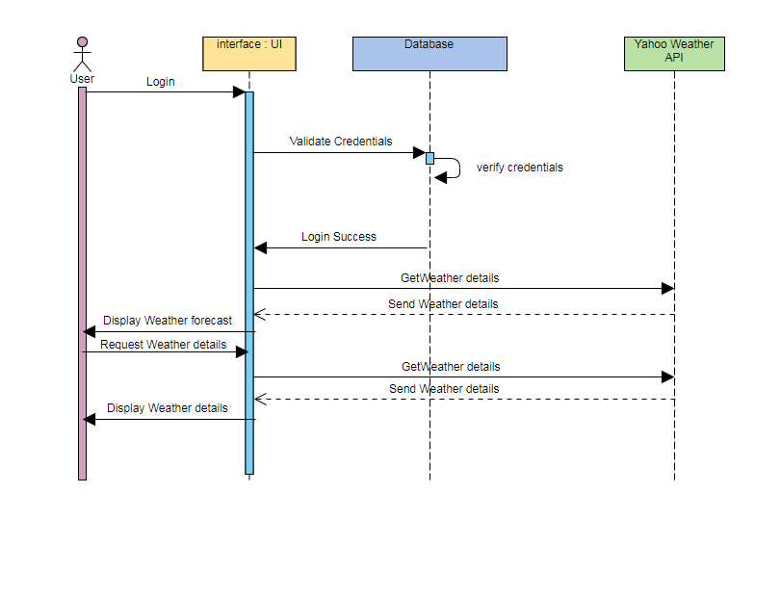

The application cant

* Display any images based on weather conditions
* Scan the real time location of user and display its forecast by default
* An email to reset password for forgot password functionality